Big Data Programming

In Class Programming - 1

Topic : Cassandra

Query Screenshots

Creation of employee table with columns empno, annualsalary, department, deptno, ename, jobtitle, hiredate and salary in Cassandra

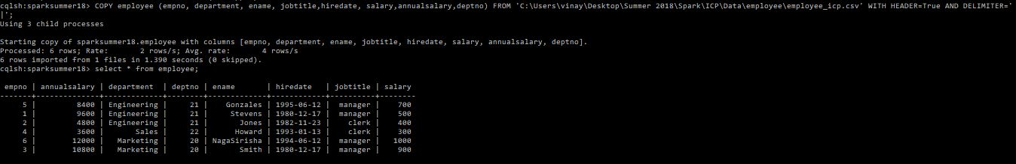

Query 1 : Fetching Empno, Ename, Jobtitle and hiredate of employee from employee table using select query.

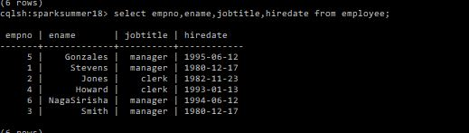

Query 2 : Fetching name, salary of the employees whose jobtitle is clerk from employee table using select query.

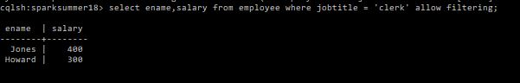

Query 3 : Fetching name, job, salary of the employees who joined on particular date using select query.



Query 4 : Fetching name and annual salary of all the employees from employee table using select query.

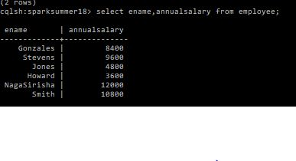

Query 5 : Fetching department name and deptno of the employees from employee table having deptno greater than or equal to 20 using select query.

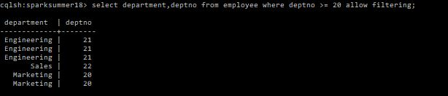

Query 6 : Fetching name, salary of the employees whose jobtitle is manager and salary is 500 dollars using select query.

